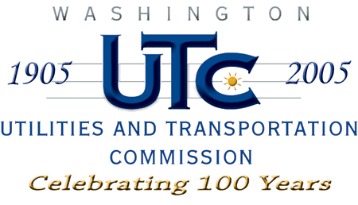

Memorandum
November 25, 2008

To: TR-071983 - File

From: Kathy Hunter, Transportation Safety Compliance Manager

Subject: TR-071983 Chehalis-Centralia Railroad and Museum
Grade Crossing Protective Fund (GCPF) Project near Chehalis

On December 27, 2007, the Washington Utilities and Transportation Commission (Commission) awarded a GCPF grant totaling $1,175 for replacement of signage at four private railroad crossings near Chehalis. Total project costs are estimated at $1,175.

On November 13, 2008, the applicant, Chehalis-Centralia Railroad and Museum submitted a request for reimbursement in the amount of $712.31 pursuant to commission order. On November 24, 2008, commission staff conducted a site visit and verified that the project is completed according to the specifications outlined in the order approving the grant.

Please close this docket.

