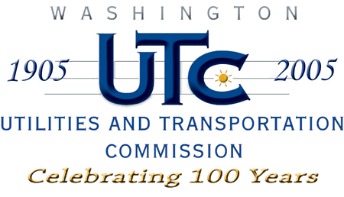

Memorandum
September 17, 2008

To: TR-071982 - File

From: Kathy Hunter, Transportation Safety Compliance Manager

Subject: TR-071982 Chehalis-Centralia Railroad and Museum
Grade Crossing Protective Fund (GCPF) Project at Spooner Road

On December 27, 2007, the Washington Utilities and Transportation Commission (Commission) awarded a GCPF grant totaling $4,850 for a project related to installation of a gate and physical barrier near the Spooner Road crossing in Lewis county. Total project costs are estimated at $4,850.

On September 8, 2008, the applicant, Chehalis-Centralia Railroad and Museum submitted a request for reimbursement in the amount of $3,418.93 pursuant to commission order. After reviewing the expenditure summary and supporting documents, staff recommends a reimbursement of $3,343.93. On September 15, 2008, commission staff conducted a site visit and verified that the project is completed according to the specifications outlined in the order approving the grant.

Please close this docket.

