 |  |  |  |  |  |  |  | Commission Docket No. |  |  |  |  |  |  |  | UT-061064
 |  |  |  |  |  |  |  | Agenda Date Assigned
BEFORE THE WASHINGTON UTILITIES AND TRANSPORTATION COMMISSION

LESS THAN STATUTORY NOTICE AND WAIVER OF CUSTOMER NOTICE RULES REQUESTED BY:

Qwest Corporation 6012957939
(Utility Name) |  |  |  |  |  |  |  |  |  |  |  |  |  | (Utility UBI Number)
(Utility d/b/a if different than registered name)
Utility proposes to change |  |  | Qwest Exchange & Network Services Tariff |  |  |  |  |  |  |  |  |  |  | Number |  | WN U-40
 | (tariff title, price list title, etc.)
Present provisions are:
Proposed changes are: To decrease the Tribal Lifeline credit towards CALC, also known as the Subscriber Line Charge, from $5.85 to $5.84. This change coincides with the decrease to the Federal Access rate for primary residential service in Washington that will become effective July 1, 2006.

Indicate below, or attach, an explanation of the reason the company requests permission to file the proposed provisions with less than statutory notice and to provide notification to customers on less than required notice.

Qwest respectfully requests for less than statutory notice, since the CALC rates were not final for filing with the FCC until June 16, 2006. The CALC rates are subject to FCC approval until they are effective on July 1, 2006. This WA filing to change the tribal lifeline credit rate was made the following week.

Jesse Nava, Filing Manager |  |  |  | is authorized to issue and file tariffs on behalf of |  |  |  |  |  |  |  |  |  |  | Qwest Corporation
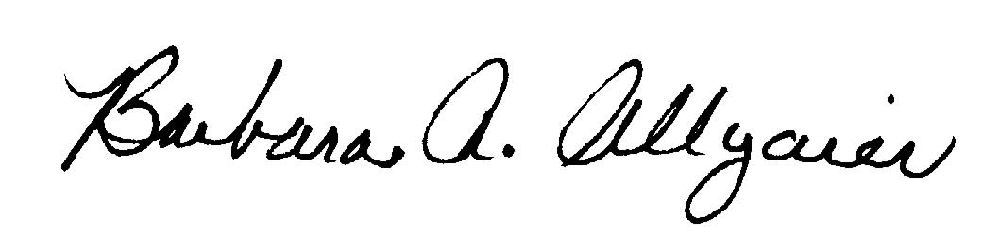  (Name and title of issuing agent) |  |  |  |  |  |  |  |  |  |  |  |  |  |  | (Name of Utility)
, Director Legal Issues
Signature and Title of Company Officer
I request these provisions become effective on |  |  |  |  | July 1, 2006
 |  |  |  |  |  |  |  |  |  | (Date)
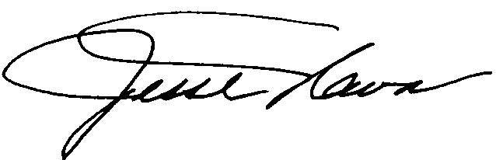 |  |  |  |  |  |  |  |  |  | Filing Managerr
(Signature of Authorized Agent) |  |  |  |  |  |  |  |  |  | (Title)
Jesse Nava
(Print Name)
(303) 896-5904 |  |  |  |  |  | (303) 896-9994 |  |  |  |  |  |  | Jesse. NavaJr@qwest.com
(Telephone Number) |  |  |  |  |  | (Fax Number) |  |  |  |  |  |  | (E-Mail Address)
1801 California Street, Suite 4740 |  |  |  |  |  | Denver |  |  |  |  |  |  | CO |  |  |  | 80202
(Mailing Address) |  |  |  |  |  | (City) |  |  |  |  |  |  | (State) |  |  |  | (Zip Code)
WASHINGTON UTILITIES AND TRANSPORTATION COMMISSION

O R D E R
The Commissioners, having determined this order is consistent with the public interest, directed the Secretary to enter this order granting the provisions requested above.
DATED and signed at Olympia, Washington, this |  |  |  |  |  |  |  |  | Day of
 |  |  |  |  |  |  |  |  |  | (Month and Year)
 |  |  |  |  |  |  |  |  |  | Secretary
Util LSN Form 02/24/04

