August 18, 2006

Carole J. Washburn,
Executive Secretary
Washington Utilities and Transportation Commission
1300 South Evergreen Park Drive, S.W.
P.O. Box 47250
Olympia, Washington 98504-7250

Subject: Rulemaking to Consider Possible Corrections and Changes to Selected Rules in Chapter 480-93 WAC, Gas Companies – Safety. Docket PG-061027

Dear Ms. Washburn:

Thank you for the opportunity to comment on the Commission’s proposal to consider possible corrections and changes to selected rules in Chapter 480-93 WAC. Avista Utilities is interested in this rulemaking and looks forward to the opportunity to review the proposed changes when they are available for comment. Avista Utilities is also interested in the intent for those proposed changes as it helps in our ability to understand the concern and provide objective comments.

Sincerely,

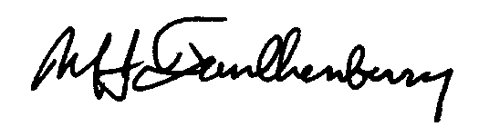

Michael J. Faulkenberry
Chief Gas Engineer

:lb

c: File
Linda Burger
Bill Baker
Mike Fink
Collin Sprague

