 | 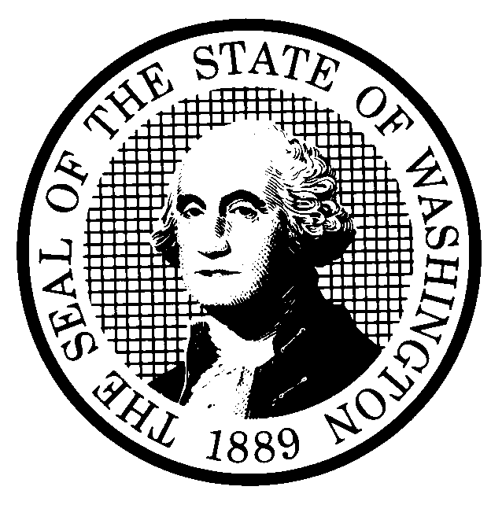 | EXPEDITED RULE MAKING |  |  |  |  | CR-105 (June 2004)  (Implements RCW 34.05.353)  EXPEDITED RULE MAKING ONLY
 | Agency: Washington Utilities and Transportation Commission
Title of rule and other identifying information: (Describe Subject) Docket No. T-051915

Repeal WAC 480-31-140 – Safety Inspections, and amend WAC 480-31-999, Adoption by reference, to remove the reference to WAC 480-31-140 in subsection (2)(b).
NOTICE
THIS RULE IS BEING PROPOSED UNDER AN EXPEDITED RULE-MAKING PROCESS THAT WILL ELIMINATE THE NEED FOR THE AGENCY TO HOLD PUBLIC HEARINGS, PREPARE A SMALL BUSINESS ECONOMIC IMPACT STATEMENT, OR PROVIDE RESPONSES TO THE CRITERIA FOR A SIGNIFICANT LEGISLATIVE RULE. IF YOU OBJECT TO THIS USE OF THE EXPEDITED RULE-MAKING PROCESS, YOU MUST EXPRESS YOUR OBJECTIONS IN WRITING AND THEY MUST BE SENT TO
Name: Executive Secretary, Docket No. T-051915
Agency: Washington Utilities and Transportation Commission
Address: PO Box 47250, Olympia, WA 98504-7250

AND RECEIVED BY (Date) April 3, 2006.

Purpose of the proposal and its anticipated effects, including any changes in existing rules:

WAC 480-31-140 requires non-profit bus service providers to keep specific records on file and subject to inspection by the Commission. These records are already required in other sections of WAC 480-31 where the Commission adopts by reference Title 49 Code of Federal Regulations; therefore, this rule is redundant.
See Attachment A.

Reasons supporting proposal: The duplicative recordkeeping requirements in the same set of rules have caused confusion for service providers. Repealing this rule will eliminate that confusion.

 | Statutory authority for adoption: RCW 81.04.160, RCW 34.05.353 |  |  |  |  | Statute being implemented: N/A
Is rule necessary because of a:  Federal Law?  Federal Court Decision?  State Court Decision?  If yes, CITATION: |  |  | Yes  Yes  Yes | No  No  No | CODE REVISER USE ONLY  Filed with the Code Reviser’s Office  January 27, 2006, 10:44 a.m.  WSR 06-04-049
DATE
January 27, 2006
NAME (TYPE OR PRINT)
Carole J. Washburn
SIGNATURE

TITLE
Executive Secretary

(COMPLETE REVERSE SIDE)

Name of proponent: (person or organization)  Washington Utilities and Transportation Commission |  |  |  | Private  Public  Governmental
Name of agency personnel responsible for:
 | Name | Office Location | Phone
Drafting............... Betty Young, Compliance Specialist |  | 1300 S. Evergreen Park Drive SW, Olympia, WA  98504-7250 | (360) 664-1202
Implementation.... Carole J. Washburn, Executive Secretary |  | 1300 S. Evergreen Park Drive SW, Olympia, WA  98504-7250 | (360) 664-1174
Enforcement..........Carole J. Washburn, Executive Secretary |  | 1300 S. Evergreen Park Drive SW, Olympia, WA  98504-7250 | (360) 664-1174
Agency comments or recommendations, if any, as to statutory language, implementation, enforcement, and fiscal matters:

None.

